**Conditions for completing the article!**

The English title is centred, Times New Roman 14, *italic* and **bold**. Justified, Times New Roman 12 font style and size, and Times New Roman 12 and **bold** for the names of the authors' scientific supervisors and chapter headings. Latin titles shall be in Times *New Roman 12 italic*. For spacing on each side and between the title, author's name, supervisor's name, study programmes, semester information, the name of the university and the layout of the chapters, **see the explanatory notes.** **Key words:** 3 to 5 words

**Length of the article:** up to two A4 pages

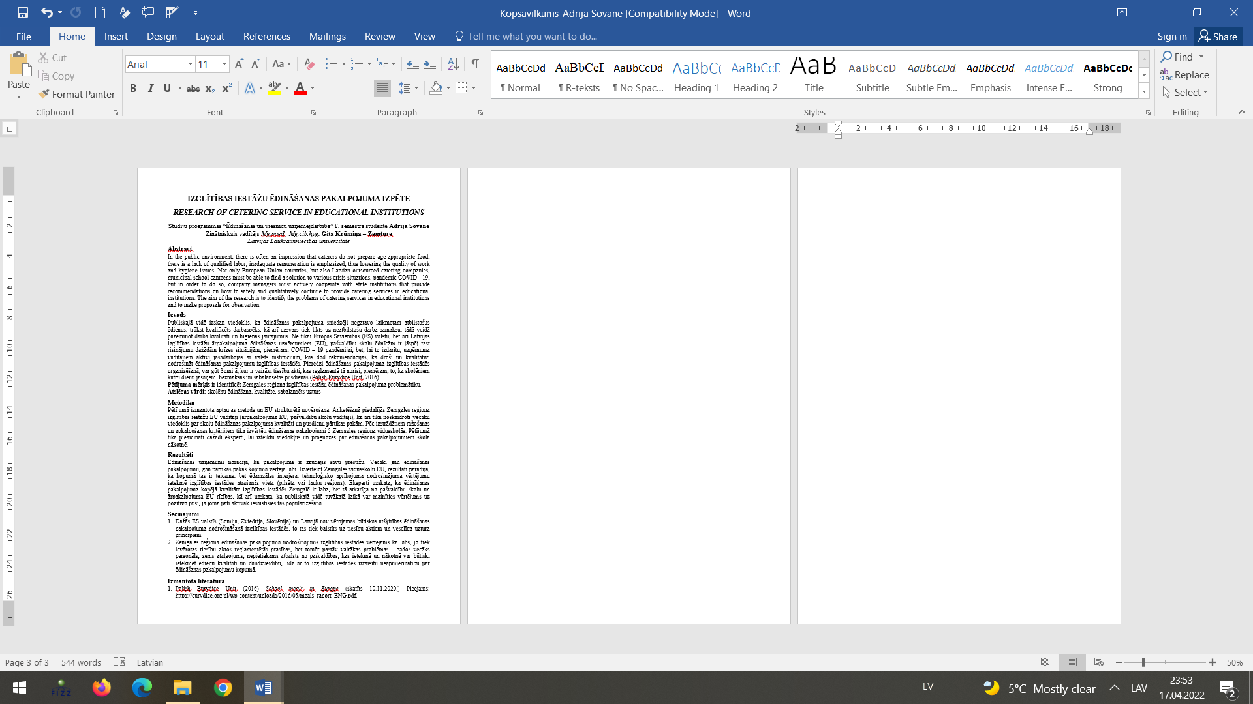

**All margins 2 cm**

**All margins 2 cm**

**All margins 2 cm**

**Introduction**

**References**

**Conclusions**

**Result**

**Methodology**

**Study objective:**

**Key words:**

**2 cm, small**

**1 x Time New Roman 14 (Enter)**

**Space AFTER student info and**

**AFTER supervisor info is 6pt**

**1 x Time New Roman 12 (Enter)**

**Space between parts of the text is 6 pt**

**List of references used and in-text citations**

|  |  |  |
| --- | --- | --- |
| **Type of source** | **Presentation of the list of sources** | **Sample for reference**  **In text** |
| One author Book | Mason P. (2020) Tourism Impacts, Planning and Management. 4th Edition. London: Routledge, 318. pp | (Mason P, 2020) |
| Two-author  Book | Koščak M., O`Rourke T. (2001) Post-Pandemic Sustainable Tourism Management. London: Routledge 164 pp. | (Koščak, O`Rourke 2021) |
| Three-author book | 1) Gursoy D., Buttle F., Bowie D. (2022) Hospitality Marketing. Principles and Practices. London: Routledge. 424 pp.  2) Feinstein A.H., Hertzman J.L., Stefanelli J.M. (2017) Purchasing: selection and procurement for the hospitality industry. Hoboken, NJ: Wiley. 690 pp. | 1) (Gursoy et.al., 2022)  2) (Fenstein et.al., 2017) |
| More than three authors  (by a collective of authors  book) | Rokasgrāmata ēdināšanas uzņēmumu vadītājiem (2007) I. Millere, L. Medne, R. Riekstiņa-Dolģe u.c. Jelgava: LLU. 176 lpp. | (Rokasgrāmata  ēdināšanas uzņēmumu ..., 2007) |
| Non-periodical  part of a non-regular publication  (e.g,  a chapter of a book  or an article in a collection) | 1) Medne L. (2017) Ēdienkartes finansiālā izvērtēšana. No: Ēdināšanas uzņēmuma vadītāja rokasgrāmata: e-grāmata.  Jelgava: LLU, 130 – 139. (skatīts 07.02.2022.)Pieejams:  <http://llufb.llu.lv/LLUgramatas/PTF/Edinasanas_uzn_vad_rokasgramata.pdf>  2) Tokareva T., Eglite A., Kaufmane D. (2017) Sustainable production and use of resources versus food wasting. In: Economy and Business, 11, 458-465. | 1) (Medne, 2017)  2) (Tokareva et al. 2017) |
| Journal article | Niederman S.A., Leonard E., Clapp J.E. (2017) Restaurant nutrition reporting and impact on surveillance. Journal of Food Composition and Analysis, 64 (1), 73-77. | (Niederman et al., 2017) |
| Article in a newspaper | Riekstiņa M. (05.02.2018) Katrai viesnīcai  savu nišu. Diena, 26, 20.lpp. | (Riekstiņa, 2018) |
| Multiple publications by the same author in different years | | Muižnieks A. (2015) ….  Muižnieks A. (2017) …. |
| If both sources are referenced | | (Muižnieks, 2015, 2017) |
| Multiple publications by the same author in the same year | | Muižnieks A. (2015a) ….  Muižnieks A. (2015b) …. |
| Institution or  an organisation as  publisher | Hotrec (2017) European hospitality industry guidelines to reduce food waste and recommendations to manage food donations. (skatīts 07.02.2022.) Pieejams: <http://www.hotrec.eu/publicationspositions.aspx> | (Hotrec, 2017) |
| Legislation  (EP regulations, laws,  Cabinet Regulations, etc.) | 1) Pārtikas aprites uzraudzības likums (1998) (skatīts 07.02.2022.) Pieejams: <https://likumi.lv/doc.php?id=47184>  2) MK noteikumi Nr.115 “Prasības fasētas pārtikas marķējumam” (2015) (skatīts 07.02.2022.) Pieejams:  <https://likumi.lv/ta/id/272619-prasibasfasetas-partikas-markejumam> | 1) (Pārtikas aprites  uzraudzības.., 1998)  2) (MK noteikumi  Nr.115, 2015) |
| Reference to 2 or  several works | 1) Dieziņa S. (2017) Restorāni: nāksies ievest darbaspēku. Dienas Bizness, 70.  2) Institute for Economics and Peace (2016) Global Peace index 2015. (skatīts 07.02.2022.) Pieejams: <http://economicsandpeace.org/wpcontent/uploads/2015/06/Global-PeaceIndex-Report-2015_0.pdf> | (Dieziņa, 2017; Institute  for Economics.., 2016) |

**Compiling a list of references used:**

* The sources included in the reference list shall be described in the language in which they were written.
* All sources cited in the reference list must be referenced in the text.
* All sources mentioned in the reference list must be publicly available.
* Bibliographical references in the reference list shall be arranged in alphabetical order by language, with works published in the Latin alphabet in the different languages being arranged first, followed by works published in the Slavic alphabet (Cyrillic).
* The list shall be numbered.
* A full stop shall be added at the end of the bibliographical reference.

**Location of references:**

* References should be enclosed in round brackets in the body of the text or at the end of the text to indicate that another author's work or idea or source of information has been used.
* If the reference refers to the whole paragraph, it should be given after the paragraph. If the reference is to a sentence or part of a sentence, the reference should precede the full stop!

**Conclusions**